Insurance database.

NAME:MEGHANA U

USN:24BECS401

1. Create a database of the name insurance.
2. Then to add contents to the database execute use database with its name.
3. Create a table person with its attributes

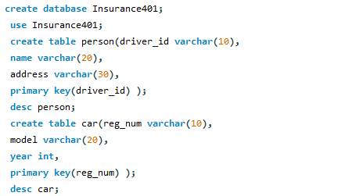

1. Create a table car with its attributes
2. Create a table accident with its attributes add primary key and foreign key.

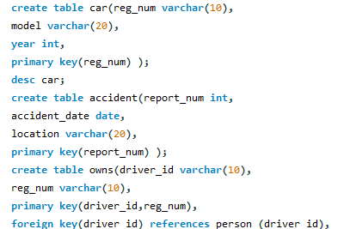

1. Create a table called as accident with its attributes and add primary key and foreign key.
2. Create a table called as participated with its attributes and add primary and foreign key.

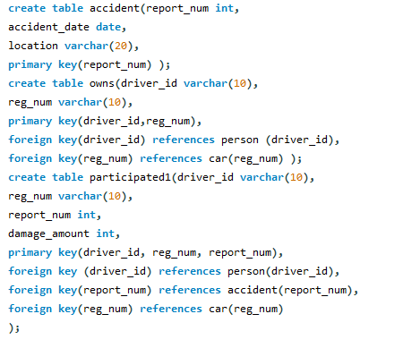

SQL QUERIES.

1. Insert the values of the person table.

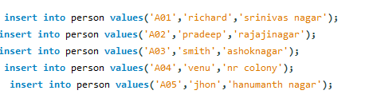

1. Insert the values of the car table.

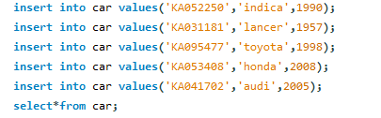

1. Insert the values of the accident values.

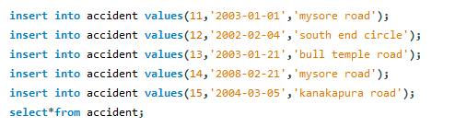

1. Insert the values of the owns table.

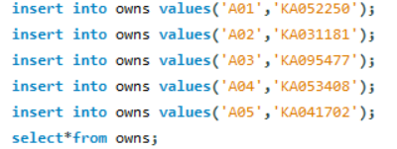

1. Insert the values of the participated tables.

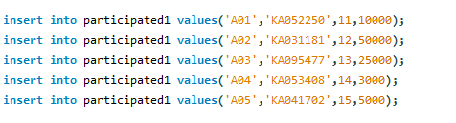

1. Update the damage amount to 25000 according to reg num=14 and the car number.



1. Count the number of driver id where the car accident year is 2004.



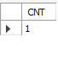

1. Insert a new column with values to the accident tables.



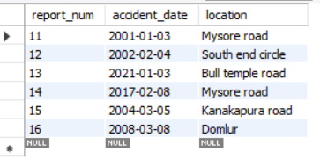

1. Select the accident date and the location from the accident table.



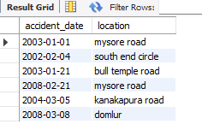

1. Display the driver id where the damage amount is greater than 25000.



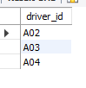

1. Display the table participated by desecending order by damge amount.



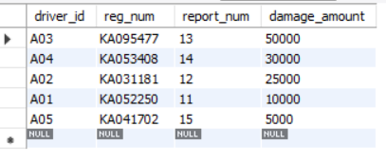

1. Display the average of the damage amount.





1. delete the tuple whose damage amount is below the average damage amount 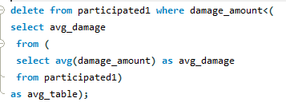
2. list the name of drivers whose damage is greater than the average damage amount.



1. find the maximum of the damge amount.



